**Boolean Algebra Worksheet**

1. Write the Boolean expression underneath each symbol:

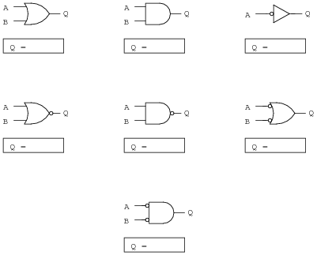

Look at these two simple logic circuits. Are they equivalent? Does it matter where the NOT gates occur?

1. Convert each logic circuit into a Boolean expression, writing each gate’s output next to the arrows:

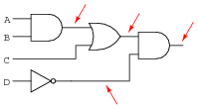

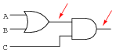

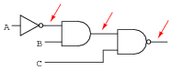

1. Complete the truth table for the following logic circuit:

|  |  |  |  |  |  |
| --- | --- | --- | --- | --- | --- |
| **A** | **B** | **C** | **D=!A** | **E=BC** | **Z=D+E** |
| 0 | 0 | 0 |  |  |  |
| 0 | 0 | 1 |  |  |  |
| 0 | 1 | 0 |  |  |  |
| 0 | 1 | 1 |  |  |  |
| 1 | 0 | 0 |  |  |  |
| 1 | 0 | 1 |  |  |  |
| 1 | 1 | 0 |  |  |  |
| 1 | 1 | 1 |  |  |  |

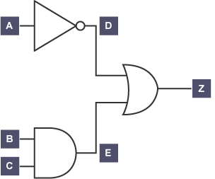

1. Write the final Boolean expression (Z) for the above diagram using the inputs A, B and C in your answer.

***Boolean Algebra Expression Symbols Reference:***

|  |  |  |
| --- | --- | --- |
| **Logic Gate** | **Boolean Symbol** | **Examples of Use** |
| AND | ∙  x  *  v  *[no gap or symbol]* | A ∙ B (common)  A x B  A * B  A v B  AB (common) |
| OR | +  ^ | A + B (common)  A ^ B |
| XOR | + | A + B |
| NOT | !  ¬  ‘ | A (common)  !A  ¬A  A’ |